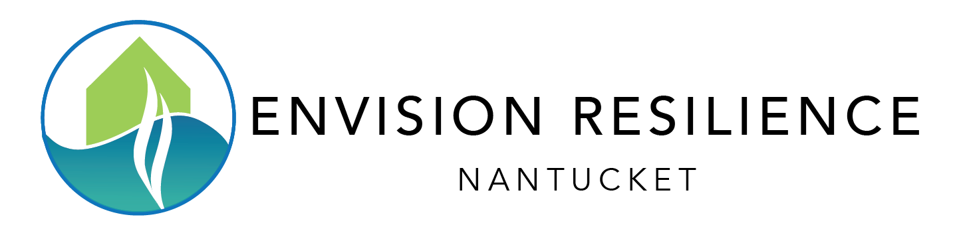

Attitudes About Climate Change and Coastal Resilience on Nantucket
Key Findings from the Envision Resilience Nantucket Challenge Surveys

ReMain Nantucket, the Envision Resilience Nantucket Challenge (ERNC), and other partners in the community have conducted a series of two surveys to measure community attitudes toward climate change and coastal resilience on Nantucket. The first survey in the series was administered between January 11-February 1, 2021, and the second survey from January 18-February 10, 2022. Nearly 1,000 Nantucket residents and visitors responded to at least one of the surveys.

Survey results demonstrate that Nantucket residents and visitors are alarmed and concerned about climate change and issues of coastal resilience. They are engaged with the topic and report that their level of engagement is increasing. Nantucket are prepared to take individual action to prepare their homes and businesses and they are supportive of their fellow homeowners, businesses, visitors, government actors, and other stakeholders in their community in their efforts to prepare for the impacts of climate change.

Key Findings
- Nantucketers continue to be alarmed by climate change
  - Both surveys found that nearly 90% of respondents to both surveys indicated that they are Alarmed or Concerned about climate change (compared with just 55% of the national population).

- Nantucketers are worried about the impacts of climate change on their island community
  - More than 70% of respondents to each survey indicated that they are “very worried” about the impacts of climate change on the Nantucket community.

- Nantucketers are increasingly engaging with issues of climate change and coastal resilience
  - 66% of respondents indicated that they are more engaged on the topic of climate change and coastal resilience than they were 12-18 months ago.

- Nantucketers agree that Nantucket government actors should play a role in helping the island prepare for the impact of climate change (but are somewhat divided over whether tax dollars should be spent to protect businesses and homes)

- Nantucketers are willing to take action to prepare their homes for the impacts of climate change and sea-level rise
- More than 70% of respondents are willing to consider installing rain gardens and raising or protecting their home’s mechanical utilities, more than 60% indicated willingness to dry floodproof their homes, and about half expressed willingness to consider wet floodproofing.Nantucketers express strong support for many community-level actions to prepare for the harmful effects of climate change and sea-level rise
  - 92% support tidal surge barriers using oyster reefs, 89% support living shorelines, and 88% support public rain gardens on Nantucket.
  - Nearly 100 respondents offered additional ideas for preparing Nantucket for sea level rise and other impacts of climate change including:

    - Deploy rain barrels throughout the island
    - Erosion control and dune and beach renourishment
    - Geotechnical tubes for beach stabilization
    - Sinking ships to create artificial reefs
    - Planting dune grass
    - Managed retreat from the most vulnerable areas
    - Education and information campaigns
    - Restricting development from vulnerable areas
    - Permeable sidewalks and other surfaces
    - Major seawall construction
    - Look to the Netherlands for sea-level rise solutions
    - Look to Germany and Denmark for alternative energy solutions

- Nantucketers are talking about climate adaptation strategies within their community, and willingness to discuss the topic is growing
  - The proportion of respondents reporting that they are “somewhat likely” or “very likely” to talk to community members about climate adaptation strategies increased from 66% on the first survey to over 70% on the second (and the proportion of respondents “very unlikely” to discuss the topic dropped from more than 8% to less than 4% between the two surveys).

- Nantucketers have read or reviewed the Town of Nantucket’s new Coastal Resilience Plan and overwhelmingly support the creation of a new funding model to pay for the municipal projects necessary to alleviate the impacts from sea-level rise
  - 70% agree or strongly agree with the plan’s goal to prepare for 9’ of sea-level rise by 2100.
  - 70% are in favor or strongly in favor of creating a new funding model.

- Nantucketers are attending climate change and coastal resilience-related events, activities, and exhibitions in their community
  - One-third of respondents to the second survey attended at least one ERNC-sponsored event, activity, or exhibition.
  - The Envision Resilience Designs for Living with Rising Seas exhibition (July-December 2021) and “Rising Above” Easy Street Light Show (October 2021) were the most popular events.

As measured by the Yale Program on Climate Change Communication’s Six Americas Super Short Survey (SASSY) scale.

